Content Management Portal (CMP) Project
Database Design Document

Document Reference: |  |  | CMP/DOCS/MQ.3
Project: |  |  | Content Management Portal (CMP)
Document Title: |  |  | Database Design
Version: |  |  | 2.0
Date: |  |  | 05 Aug 2009
Prepared/Revised by: |  |  | Rajendran Kumaraguru
Approved by :
 |  | Sui Haiyang |  |  | Date
 |  | Project Manager
 | © 2009  The information contained in this document is the property of ISS. The contents must not be copied in whole or in part for purposes other than which it has been supplied without the consent of ISS, or, if it has been furnished under contract to another party, as expressly authorised under that contract, then ISS shall not be liable for any errors or omissions. |  |  | 
Institute of Systems Science, 25 Heng Mui Keng Terrace,
Singapore 119615
Version History Record
Version | Date | Brief description of amendments and affected pages, paragraph
0.1 | 05/08/09 | Draft Issue
1.0 | 10/11/09 | Release after Internal Review
1.1 | 16/12/09 | Changed based on review , development and testing
1.2 | 07/01/10 | Changed the data type and column name user id to user name for mcq user exam table.
2.0 | 10/01/10 | Released

Name | Department | Organisation
ISS Audit | ISS | ISS
Sui Haiyang | Project Manager | ISS-SE16S07
Gao Jia Si Karen | Quality Manager | ISS-SE16S07
Yap Sie Kuok, Thomas | Testing Manager | ISS-SE16S07
May Ann Sallan | Database Designer | ISS-SE16S07
Rajendran Kumaraguru | System Architect | ISS-SE16S07
Thiyagarajan Ravikumar | Technical Lead | ISS-SE16S07

Table of Contents
1. Introduction 5
2. List of tables 5
3. DB Diagram 8
4. Tables Structure 11
4.1 MCQ EXAM MASTER 14
4.2 MCQ SECTION MASTER 14
4.3 MCQ QUESTION MASTER 16
4.4 MCQ USER EXAM 17
4.5 MCQ EXAM RESULT 18
4.6 MCQ EXAM SECTION RESULT 18
4.7 MCQ QUESTION OPTIONS 19
4.8 MCQ USER ANSWER 20
4.9 SURVEY MASTER 20
4.10 SURVEY QUESTION OPTIONS 21
4.11 SURVEY QUESTION MASTER 21
4.12 SURVEY RESULT 22
4.13 MODULE MASTER 23
4.14 COMPANY MODULE 24
4.15 CMS USER CONTENT USAGE 25
4.16 COMPANY SITES 25
4.17 CMS SITE 26
4.18 JMD USER ROLE 27
4.19 DAP MASTER 27
4.20 DAP LIST 28
4.21 FAP LIST 29
4.22 FAP MASTER 29
4.23 FAP FUNCTION 30
4.24 JMD USER 30
4.25 JMD USER ADDRESS 31
4.26 USER ROLE 33
4.27 JMD ROLE 33
4.28 COMPANY MASTER 34
4.29 USER MASTER 35
4.30 ROLE LIST 35
4.31 ROLE DAP 36
4.32 ROLE FAP 37
4.33 USER ADMIN LIST 37
4.34 USERADMIN_MASTER 38
4.35 USER LIST 38
4.36 JMD DIV 39
4.37 JMD MOD 40
4.38 JMD MODULE ADMIN 41
4.39 JMD_OBJ 42
4.40 JMD MODULE CJ CATEGORY 42
4.41 JMD MODULE HTML 43
4.42 JMD PAGE MODULE 43
4.43 JMD PAGE 44
4.44 JMD COL EXT 46
4.45 JMD COLD TYPE 46
4.46 JMD PAGE MOD EXCLUDE 47
4.47 JMD SITE 47
4.48 JMD COL 48
4.49 CMS SITE OUTLINE 49
4.50 CMS SITE TREEVIEW 49

Introduction
This document describes about initial database design for the CMP application. It contains various database tables which are going to be implemented across different modules of the application. The database is designed in db normalization structure. Each table is having the associations with either master or detail table. During the development phase some part of the tables would be changed according to the development.

List of tables
Below table gives the summary of usage of the each tables which will be created for Content Management Portal Application.
Sl No | Table Name | Description
1 | Company_Master | Stores the company information while registering the company.
2 | User_master | Stores the user information upon successful registration of the company.
3 | Fap_master | List of program will be identified and stored for the entire system.
4 | Dap_master | List of data access will be stored for the entire system to restrict the data access at different company levels.
5 | Role_master | Different type of roles will be created for the entire system access. Each role contains several faps and daps and it will be assigned to particular user or group of users.
6 | Mcq_master | MCQ main information will be stores like particular mcq will belong to which section and module.
7 | Mcq_pool_master | List of questions will be stored under this table for MCQ.
8 | Mcq_answers | List of answers will be stored for each mcq.
9 | Mcq_tran_details | When the customer attends the mcq portion the complete transaction details will be stored.
10 | Module_master | Module master information will be stored in this table.
11 | Content_master | Store the uploaded content information in this table which contains section for the uploaded content, total pages as well as property of the uploaded content.
12 | Content_properties | Uploaded content property information will be stored under this table.
13 | Cms_subscription_details | Stores the subscription details for the content. Whenever the customer visits the particular content those information will be stored under this table.
14 | Cmp_survey | Master table which stores the survey information.
15 | Cmp_survey_trans | Detail table which stores the survey transactions details.
16 | Cms_div | Stores the division information for the uploaded content. And it will have either child divisions and parent division of the uploaded content.
17 | Cms_mod | Each uploaded content module will be stored with respective site id and name of the module.
18 | Cms_mod_admin | Stores the module information as well as property of uploaded module.
19 | Cms_obj | Contains module object information.
20 | Cms_mod_cj_category | If there is any insertions into the existing module those information will be stored under this table.
21 | Cms_mod_html | Each uploaded content html information will be stored under this table like site url version folder name etc.
22 | Cms_page_mod | Stores uploaded content page information in this table.
23 | Cms_col_ext | If there is an inclusion into the existing sections of the uploaded content those information will be stored under this table.
24 | Cms_col_type | Internal table to store the column types of the uploaded content.
25 | Cms_page | Store the uploaded content pagination information for the tree view of the application.
26 | Cms_site | Stores the uploaded site url for the uploaded content.
27 | Cms_col | Internal table to store the uploaded content column details.
28 | Cms_page_mod_exclude | If any particular page of the module has to be excluded from the uploaded content those information will be stored under this table.

DB Diagram
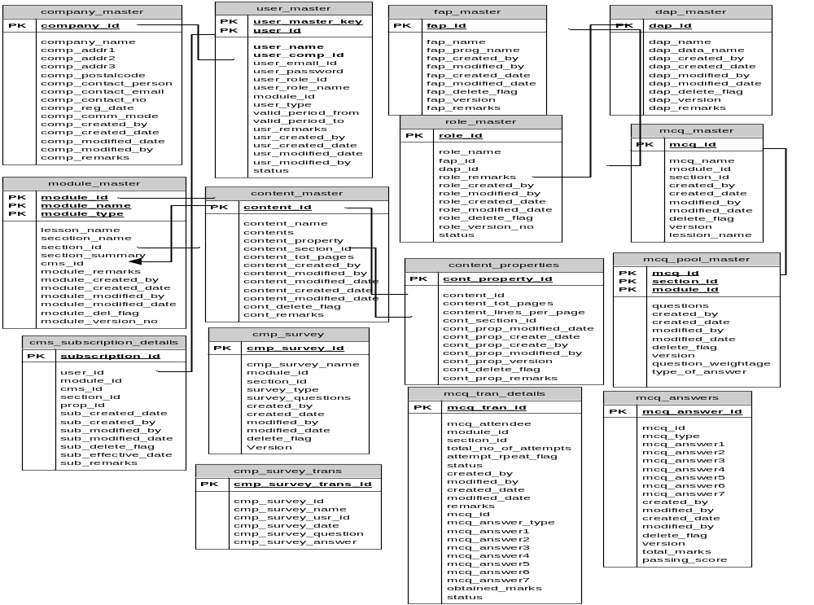

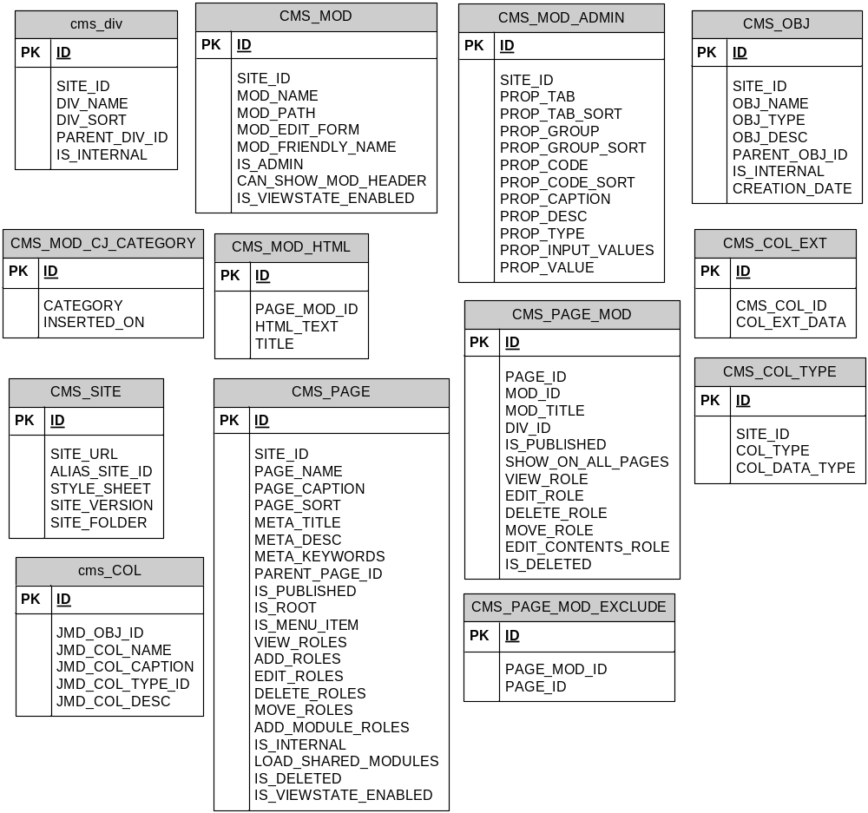

DB Diagram

MCQ EXAM MASTER
Table Name | MCQ_EXAM_MASTER
Module | MCQ
Description | This table store the MCQ (Multiple Choice Question) details

No | Column Description | Data Type & Size | Remarks
1 | EXAM_ID | NUMERIC | Stores the examination ID
2 | EXAM_NAME | VARCHAR(50) | Stores the examination Name
3 | EXAM_ABBR | VARCHAR(50) | Stores the examination details.
4 | TOTAL_QNS | [NUMERIC](5, 0) | Total questions for each exam id
5 | TOTAL_MARKS | [NUMERIC](3, 0) | Total Marks for each exam id
6 | PASS_MARK | [NUMERIC](2, 0) | Total pass mark for each exam id
7 | EXAM_DURATION | [NUMERIC](10, 3) | Duration of the exam. This will be tracked during the examination.
8 | CREATED_BY | VARCHAR(50)
9 | CREATED_DATE | [DATETIME]
10 | MODIFIED_BY | VARCHAR(50)
11 | MODIFIED_DATE | [DATETIME]
12 | DELETE_FLAG | VARCHAR(2)

MCQ SECTION MASTER
Table Name | MCQ_SECTION_MASTER
Module | MCQ
Description | This table stores the section detail for the associated exam id for list of questions for each section.

No | Column Description | Data Type & Size | Remarks
1 | EXAM_ID | NUMERIC | Stores the examination ID
2 | SECTION_ID | VARCHAR(20) | Store the section id for the particular module.
3 | SECTION_NAME | VARCHAR(50) | Stores the section name for the particular module.
4 | SECTION_ABBR | VARCHAR(50) | Stores the abbreviation detail for the particular module.
5 | SECTION_SEQ | [NUMERIC](3, 0) | Under each module the sequence of the module will be stored here.
6 | SECTION_WEIGHT | [NUMERIC](3, 0) | Each section the weight age of the marks will be stored.
7 | TOTAL_SIMPLE_QNS | [NUMERIC](3, 0) | If any sample questions then it stores the total no. of questions.
8 | SIMPLE_QN_WEIGHT | [NUMERIC](3, 0) | Each section the weight age of the marks will be stored.
9 | TOTAL_MODERATE_QNS | [NUMERIC](3, 0) | If any moderate questions then it stores the total no. of questions.
10 | MODERATE_QN_WEIGHT | [NUMERIC](3, 0) | Each section the weight age of the marks will be stored.
11 | TOTAL_COMPLEX_QNS | [NUMERIC](3, 0) | Stores the total complex questions per module and per exam.
12 | COMPLEX_QN_WEIGHT | [NUMERIC](3, 0) | Stores the weight age of each section.
13 | CREATED_BY | VARCHAR(50)
14 | CREATED_DATE | [DATETIME]
15 | MODIFIED_BY | VARCHAR(50)
16 | MODIFIED_DATE | [DATETIME]
17 | DELETE_FLAG | VARCHAR(2)

MCQ QUESTION MASTER
Table Name | MCQ_QUESTION_MASTER
Module | MCQ
Description | This table stores the question detail with associated section.

No | Column Description | Data Type & Size | Remarks
1 | EXAM_ID | NUMERIC | Stores the examination id
2 | SECTION_ID | VARCHAR(20) | Stores the section id to link with section detail.
3 | QUESTION_ID | VARCHAR(25) | Stores the question id.
4 | QUESTION_TEXT | VARCHAR(250) | Stores the question for each question id.
6 | EXAM_TYPE | VARCHAR(25) | Type of the question whether is it is simple, moderate or complex.
7 | QUESTION_LEVEL | VARCHAR(25)
8 | QUESTION_TYPE | VARCHAR(10) | Type of the question whether is it is simple, moderate or complex.
9 | CREATED_BY | VARCHAR(50)
10 | CREATED_DATE | [DATETIME]
11 | MODIFIED_BY | VARCHAR(50)
12 | MODIFIED_DATE | [DATETIME]
 | DELETE_FLAG | VARCHAR(2)

MCQ USER EXAM
Table Name | MCQ_USER_EXAM
Module | MCQ
Description | Stores about the user information which are related to the examination.

No | Column Description | Data Type & Size | Remarks
1 | USER_EXAM_ID | VARCHAR(25) | Stores about user examination id.
2 | EXAM_ID | VARCHAR(25) | Stores the examination id.
3 | USER_NAME | VARCHAR(50) | Stores about user id.
9 | QN_ID | VARCHAR(25) | Stores the question id for the particular exam and user id to link back with choice master.
10 | EXAM_DATE | [DATETIME] | Date of the examination.
11 | CREATED_BY | VARCHAR(50)
12 | CREATED_DATE | [DATETIME]
13 | MODIFIED_BY | VARCHAR(50)
14 | MODIFIED_DATE | [DATETIME]
15 | DELETE_FLAG | VARCHAR(2)

MCQ EXAM RESULT
Table Name | MCQ_EXAM_RESULT
Module | MCQ
Description | Stores about the examination result for the particular user id.

No | Column Description | Data Type & Size | Remarks
1 | EXAM_ID | VARCHAR(25) | Stores the examination id.
2 | USER_ID | VARCHAR(10) | Stores the user id who is taking the examination.
3 | QN_ID | VARCHAR(25) | Stores the section for the module.
4 | RESULT | [NUMERIC](5, 2) | Stores the marks information for the examination attended.
5 | TOTAL_TIME_TAKEN | [NUMERIC](5, 2) | Duration of the exam the user has appeared.
6 | CREATED_BY | VARCHAR(50)
7 | CREATED_DATE | [DATETIME]
8 | MODIFIED_BY | VARCHAR(50)
9 | MODIFIED_DATE | [DATETIME]
10 | DELETE_FLAG | VARCHAR(2)

MCQ EXAM SECTION RESULT
Table Name | MCQ_EXAM_SECTION_RESULT
Module | MCQ
Description | Stores about the examination result for the particular user id.

No | Column Description | Data Type & Size | Remarks
1 | EXAM_ID | VARCHAR(25) | Stores the examination id.
2 | USER_ID | VARCHAR(10) | Stores the user id who is taking the examination.
3 | SECTION_ID | VARCHAR(25) | Stores the section for the module.
4 | MARKS | [NUMERIC](5, 2) | Stores the marks information for the examination attended.
5 | DURATION | [NUMERIC](5, 2) | Duration of the exam the user has appeared.
6 | CREATED_BY | VARCHAR(50)
7 | CREATED_DATE | [DATETIME]
8 | MODIFIED_BY | VARCHAR(50)
9 | MODIFIED_DATE | [DATETIME]
10 | DELETE_FLAG | VARCHAR(2)

MCQ QUESTION OPTIONS
Table Name | MCQ_QUESTION_OPTIONS
Module | MCQ
Description | This tables stores the mcq question options.

No | Column Description | Data Type & Size | Remarks
1 | OPTION_ID | NUMERIC | Stores the option id
2 | QUESTION_ID | NUMERIC | Stores the question id
3 | OPTTEXT | VARCHAR(50) | Stores the optional text
4 | ISANSWER | VARCHAR(50) | Stores the answer.

MCQ USER ANSWER
Table Name | MCQ_USER_ANSWER
Module | MCQ
Description | Stores the MCQ user answers

No | Column Description | Data Type & Size | Remarks
1 | MCQ_USER_ANSWER_ID | NUMERIC | Stores the answer id
2 | USER_EXAM_ID | NUMERIC | Stores the exam id
3 | CHOICE_ID | NUMERIC | Stores the choice id
4 | CORRECT | VARCHAR | Stores the indicator whether the answer is correct or wrong.

SURVEY MASTER
Table Name | SURVEY_MASTER
Module | Survey
Description | This tables stores the information about survey.

No | Column Description | Data Type & Size | Remarks
1 | SURVEY_ID | VARCHAR(25) | Stores the survey id.
2 | SURVEY_NAME | VARCHAR(50) | Stores the name of the survey.
3 | SURVEY_ABBR | VARCHAR(50) | Stores the abbreviation of survey.
4 | CREATED_BY | VARCHAR(50)
5 | CREATED_DATE | [DATETIME]
6 | MODIFIED_BY | VARCHAR(50)
7 | MODIFIED_DATE | [DATETIME]
8 | DELETE_FLAG | VARCHAR(2)

SURVEY QUESTION OPTIONS

Table Name | SURVEY_QN_OPTIONS
Module | MCQ
Description | Stores the survey question options.

No | Column Description | Data Type & Size | Remarks
1 | OPT_ID | NUMERIC | Stores the option id
2 | QUESTION_ID | NUMERIC | Stores the question id
3 | CHOICE | VARCHAR(50) | Stores the choice details.

SURVEY QUESTION MASTER
Table Name | SURVEY_QN_MASTER
Module | Survey
Description | Stores the question information which are related to particular survey.

No | Column Description | Data Type & Size | Remarks
1 | SURVEY_ID | VARCHAR(25) | Stores the survey id as a primary key.
2 | QN_ID | VARCHAR(25) | Question id for particular survey.
3 | QN | VARCHAR(50) | Stores the question information.
4 | QN_TYPE | VARCHAR(25) | Stores information about difficulties of the question.
5 | CREATED_BY | VARCHAR(50)
6 | CREATED_DATE | [DATETIME]
7 | MODIFIED_BY | VARCHAR(50)
8 | MODIFIED_DATE | [DATETIME]
9 | DELETE_FLAG | VARCHAR(2)

SURVEY RESULT
Table Name | SURVEY_RESULT
Module | Survey
Description | Stores the result of the survey which is already completed for a particular organization.

No | Column Description | Data Type & Size | Remarks
1 | USER_SURVEY_ID | VARCHAR(25) | User id who is already completed the survey.
2 | SURVEY_ID | VARCHAR(25) | Which survey user has taken.
3 | USER_ID | VARCHAR(10) | User Id for tracking back with user master table.
4 | QN_ID | VARCHAR(25) | Question id to track back with question master table.
5 | SURVEY_USER_ANSWER | VARCHAR(250) | Answer detail for the user who is already completed.
6 | EXAM_DT | VARCHAR(50) | Date of the examination.
7 | CREATED_BY | VARCHAR(50)
8 | CREATED_DATE | [DATETIME]
9 | MODIFIED_BY | VARCHAR(50)
10 | MODIFIED_DATE | [DATETIME]
11 | DELETE_FLAG | VARCHAR(2)

MODULE MASTER
Table Name | MODULE_MASTER
Module | CMS
Description | Stores the information about the uploaded module for the particular organization.

No | Column Description | Data Type & Size | Remarks
1 | MODULE_ID | NUMERIC | Stores the module id.
2 | MODULE_NAME | VARCHAR(50) | Stores the name of the module which is uploaded.
3 | MODULE_REMARKS | VARCHAR(500) | Stores any particular remarks for the module.
4. | MODULE_TYPE | VARCHAR(50) | Stores the different types of module.
5 | CREATED_BY | VARCHAR(50)
6 | CREATED_DATE | [DATETIME]
7 | MODIFIED_BY | VARCHAR(50)
8 | MODIFIED_DATE | [DATETIME]
9 | DELETE_FLAG | VARCHAR(2)

COMPANY MODULE
Table Name | COMPANY_MODULE
Module | ACS
Description | Stores the organization information who is purchased this service.

No | Column Description | Data Type & Size | Remarks
1 | COMPANY_MODULE_ID | VARCHAR(25) | Stores the information about module id for the particular organization.
2 | COMPANY_ID | VARCHAR(50) | Stores unique company id.
3 | MODULE_ID | VARCHAR(50)
4 | CREATED_BY | VARCHAR(50)
5 | CREATED_DATE | [DATETIME]
6 | MODIFIED_BY | VARCHAR(50)
7 | MODIFIED_DATE | [DATETIME]
8 | DELETE_FLAG | VARCHAR(2)

CMS USER CONTENT USAGE
Table Name | CMS_USER_CONTENT_USAGE
Module | CMS
Description | This table stores the information about user usage on the learning or survey or mcq.

No | Column Description | Data Type & Size | Remarks
1 | USER_ID | VARCHAR(25) | Stores the user id who is logged in for learning purpose.
2 | SITE_ID | VARCHAR(50) | Which site user has used for specific module learning.
3 | CMS_PAGE_ID | VARCHAR(25) | Stores the information about the page user has visited, this will be tracking back to master table to identify the usage.
4 | DURATION_SPEND | [NUMERIC](5, 0) | Duration of the time per page.
5 | CREATED_BY | VARCHAR(50)
6 | CREATED_DATE | [DATETIME]
7 | MODIFIED_BY | VARCHAR(50)
8 | MODIFIED_DATE | [DATETIME]
9 | DELETE_FLAG | VARCHAR(2)

COMPANY SITES
Table Name | COMPANY_SITES
Module | CMS
Description | Stores the sites which have been created for an organization at module level.

No | Column Description | Data Type & Size | Remarks
1 | COMPANY_ID | VARCHAR(25) | Stores the company information which will was created thru ACS module.
2 | SITE_ID | VARCHAR(50) | Stores the module information as site id and it will be linked back to site master.
3 | CREATED_BY | VARCHAR(50)
4 | CREATED_DATE | [DATETIME]
5 | MODIFIED_BY | VARCHAR(50)
6 | MODIFIED_DATE | [DATETIME]
7 | DELETE_FLAG | VARCHAR(2)

CMS SITE

Table Name | CMS_SITE
Module | CMS
Description

No | Column Description | Data Type & Size | Remarks
1 | JMD_OBJ_ID | VARCHAR(50)
2 | JMD_COL_NAME | VARCHAR(250)
3 | CREATED_BY | VARCHAR(50)
4 | JMD_CAPTION | VARCHAR(250)
5 | JMD_TYPE_ID | VARCHAR(50)
6 | JMD_TYPE_DESC | VARCHAR(250)
7 | CREATED_BY | VARCHAR(50)
8 | CREATED_DATE | [DATETIME]
9 | MODIFIED_DATE | [DATETIME]
10 | DELETE_FLAG | VARCHAR(2)

JMD USER ROLE
Table Name | JMD_USER_ROLE
Module | ACS
Description | Stores the jmd user roles

No | Column Description | Data Type & Size | Remarks
1 | ID | NUMBER | Running sequence no.
2 | USER_ID | NUMBER | Stores the user id
3 | ROLES | VARCHAR2(1000) | Stores the roles detail.

DAP MASTER
Table Name | DAP_MASTER
Module | ACS
Description | Stores the details about data access profile.

No | Column Description | Data Type & Size | Remarks
1 | DAPMASTERID | NUMBER | Data access profile id
2 | DAPLISTID | NUMBER | Name of the data access name.
3 | DAPMODULEID | NUMBER | Stores the module id which will be  Taken as dap.

DAP LIST
Table Name | DAP_LIST
Module | ACS
Description | Stores the detail about Data Access Profiles.

No | Column Description | Data Type & Size | Remarks
1 | DAPLISTID | VARCHAR(25) | Stores the DAP id which will be used to create roles.
2 | DAPNAME | VARCHAR(25) | List of associated data profiles tagged with dap id and it will be used to create the roles.
3 | CREATED_BY | VARCHAR(50)
4 | CREATED_DATE | [DATETIME]
5 | MODIFIED_BY | VARCHAR(50)
6 | MODIFIED_DATE | [DATETIME]
7 | DELETE_FLAG | VARCHAR(2)
8. | DAP_REMARK | VARCHAR | Stores the remark for the FAP.

FAP LIST

Table Name | FAP_LIST
Module | ACS
Description | Stores the detail about Functional Access Profiles.

No | Column Description | Data Type & Size | Remarks
1 | FAP_LIST_ID | VARCHAR(25) | Stores the FAP id which will be used to create roles.
2 | FAPNAME | VARCHAR(25) | List of associated functions tagged with fap id and it will be used to create the roles.
3 | CREATED_BY | VARCHAR(50)
4 | CREATED_DATE | [DATETIME]
5 | MODIFIED_BY | VARCHAR(50)
6 | MODIFIED_DATE | [DATETIME]
7 | DELETE_FLAG | VARCHAR(2)
8. | FAP_REMARK | VARCHAR | Stores the remark for the FAP.

FAP MASTER
Table Name | FAP_MASTER
Module | ACS
Description | Stores the list of functional access profile name and associated program names thru ACS module.

No | Column Description | Data Type & Size | Remarks
1 | FAPMASTERID | NUMERIC | Stores the primary key for functional profile id.
2 | FAPLISTID | VARCHAR(50) | Name of the program which will be linked to particular id.
3 | FAPFUNCTIONID | VARCHAR(50) | Stores the functional id.

FAP FUNCTION
Table Name | FAP_FUNCTION
Module | ACS
Description | Stores the details about data access profile.

No | Column Description | Data Type & Size | Remarks
1 | FAPFUNCTIONID | NUMBER | Stores the fap function id.
2 | FAP_FUNCTION | VARCHAR(50) | Name of the function
3 | CREATED_BY | VARCHAR(50)
4 | CREATED_DATE | [DATETIME]
5 | MODIFIED_BY | VARCHAR(50)
6 | MODIFIED_DATE | [DATETIME]
7 | DELETE_FLAG | VARCHAR(2)
8 | FUNCTION_REMARKS | VARCHAR(50)

JMD USER
Table Name | JMD_USER
Module | ACS
Description | Stores user information for the company.

No | Column Description | Data Type & Size | Remarks
1 | ID | NUMBER | Site ID which will be linked back to site master.
2 | SITE_ID | NUMBER | Stores Site ID
3 | USER_NAME | VARCHAR( 50) | Name of the user
4 | USER_DISPLAY_NAME | VARCHAR(50) | Display name of the user.
5 | PASSWORD_HASH | VARCHAR(50) | Stores the password
6 | SALT | VARCHAR(50) | User salutation
7 | IS_INTERNAL | VARCHAR(50) | Indicates whether the user is internal user or not.
8 | EMAIL | VARCHAR(50)
9 | STATUS | VARCHAR(50)
10 | CREATION_DATE | DATETIME
11 | VALID_FROM | DATETIME
12 | VALID_TO | DATETIME
13 | ACTIVATION_KEY | VARCHAR(100)

JMD USER ADDRESS
Table Name | JMD_USER_ADDRESS
Module | ACS
Description | Stores users personal information.

No | Column Description | Data Type & Size | Remarks
1 | ID | NUMBER
2 | USER_ID | NUMBER
3 | ADDRESS1 | VARCHAR( 50)
4 | ADDRESS2 | VARCHAR(250)
5 | ADDRESS3 | VARCHAR(50)
6 | CITY_ID | VARCHAR(50)
7 | COUNTY_ID | VARCHAR(50)
8 | STATE_ID | [DATETIME]
9 | COUNTRY_ID | [DATETIME]
10 | IS_PRIMARY | VARCHAR(2)
11 | PHONE_HOME
12 | PHONE_WORK
13 | PHONE_CELL
14 | EMAIL1
15. | EMAIL2
16 | EMAIL3
17 | WEB1
18. | WEB2
19 | WEB3

USER ROLE

Table Name | USER_ROLE
Module | ACS
Description | Roles which are created thru ACS module will be stored in this table. This will have the combination of FAPs and DAPs.

No | Column Description | Data Type & Size | Remarks
1 | ID | NUMERIC | Running sequence no.
2 | USER_ID | NUMERIC | User ID Running sequence no.
3 | ROLES | VARCHAR(1000)

JMD ROLE

Table Name | JMD_ROLE
Module | ACS
Description | Stores the roles for the system.

No | Column Description | Data Type & Size | Remarks
1 | ID | NUMBER | Running sequence no.
2 | SITE_ID | NUMBER | Stores the Site ID.
3 | ROLE_NAME | VARCHAR(50) | Stores name of the role
4 | IS_INTERNAL | NUMBER | Indicates whether it is internal role i.e. for portal admin or external role i.e. user admin or users..
5 | PARENT_ROLE | NUMBER | Indicate whether the created role is pare

COMPANY MASTER
Table Name | COMPANY_MASTER
Module | ACS
Description | Stores the Organization detail.

No | Column Description | Data Type & Size | Remarks
1 | COMPANYID | NUMBER | Stores the organization id which new company is being registered.
2 | COMPANYNAME | VARCHAR(100) | Name of an organization.
3 | COMPANYADDRESS1 | VARCHAR(150) | Address of organization.
4 | COMPANYADDRESS2 | VARCHAR(150) | Address of organization.
5 | COMPANYADDRESS3 | VARCHAR(150) | Address of organization.
6 | POSTALCODE | VARCHAR(12) | Address of organization.
7 | CONTACTPERSON | VARCHAR(50) | Contact representative name for the company
8 | CONTACTEMAIL | VARCHAR(50) | Email id for registering organization.
9 | CONTACTNO | VARCHAR(50) | Contract for registering organization.
10 | SUBSCRIBEDATE | [DATETIME] | Registration starting date.
11 | COMMMODE | VARCHAR(12) | Mode of communication between the client and company
12 | CREATED_DATE | [DATETIME]
13 | VALID_PERIOD_FROM | [DATETIME] | Validity date for the registered company.
14 | VALID_PERIOD_TO | [DATETIME] | Till when the subscription of the service is valid.
15 | CREATED_BY | VARCHAR(50)
16 | CREATED_DATE | [DATETIME]
17 | MODIFIED_BY | VARCHAR(50)
18 | MODIFIED_DATE | [DATETIME]
19 | DELETE_FLAG | VARCHAR(2)
20 | COMPANY_REMARK | VARCHAR(500) | Any specific remarks while creating the company.

USER MASTER
Table Name | USER_MASTER
Module | ACS
Description | Stores the detail about users or portal admin per organization

No | Column Description | Data Type & Size | Remarks
1 | USERMASTERID | NUMBER
2 | USERLISTID | NUMBER | Stores the user id
3 | ROLELISTID | NUMBER | Name of the user will be stored

ROLE LIST

Table Name | ROLE_LIST
Module | ACS
Description | Stores the Role list for ACS

No | Column Description | Data Type & Size | Remarks
1 | ROLELISTID | VARCHAR(50)
2 | ROLENAME | VARCHAR(250)
3 | CREATED_BY | VARCHAR(50)
4 | CREATED_DATE | [DATETIME]
5 | MODIFIED_BY | VARCHAR(50)
6 | MODIFIED_DATE | [DATETIME]
7 | ROLE_REMARK | VARCHAR(500)
8 | DELETE_FLAG | VARCHAR(2)

ROLE DAP
Table Name | ROLE_DAP
Module | ACS
Description | Stores Dap roles

No | Column Description | Data Type & Size | Remarks
1 | ROLEDAPID | NUMERIC
2 | ROLELISTID | NUMERIC
3 | DAPLISTID | NUMERIC

ROLE FAP
Table Name | ROLE_FAP
Module | ACS
Description | Stores fap roles

No | Column Description | Data Type & Size | Remarks
1 | ROLEFAPID | NUMERIC
2 | ROLELISTID | NUMERIC
3 | FAPLISTID | NUMERIC

USER ADMIN LIST

Table Name | USERADMIN_LIST
Module | ACS
Description | Stores user admin list

No | Column Description | Data Type & Size | Remarks
1 | USERADMINLISTID | VARCHAR(50)
2 | COMPANYID | VARCHAR(250)
3 | USERADMINNAME | VARCHAR(50)
4 | USERADMINPASS | VARCHAR(250)
5 | CREATED_BY | VARCHAR(50)
6 | CREATED_DATE | [DATETIME]
7 | MODIFIED_BY | VARCHAR(50)
8 | MODIFIED_DATE | [DATETIME]
9 | DELETE_FLAG | VARCHAR(2)
10 | USER ADMIN REMARK | VARCHAR(500)

USERADMIN_MASTER

Table Name | USERADMIN_MASTER
Module | ACS
Description | Stores the user admins

No | Column Description | Data Type & Size | Remarks
1 | USERADMINMASTERID | NUMERIC
2 | USERADMINLISTID | NUMERIC
3 | ROLELISTID | NUMERIC

USER LIST

Table Name | USER_LIST
Module | ACS
Description | Stores the user list

No | Column Description | Data Type & Size | Remarks
1 | USERLISTID | VARCHAR(50)
2 | USERNAME | VARCHAR(50)
3 | USERADMINID | NUMERIC
4 | USERPASS | VARCHAR(50)
5 | CREATED_BY | VARCHAR(50)
6 | CREATED_DATE | [DATETIME]
7 | MODIFIED_DATE | [DATETIME]
8 | MODIFIED_BY | VARCHAR(50)
9 | USER_REMARK | VARCHAR(500)
10 | DELETE_FLAG | VARCHAR(2)

JMD DIV
Table Name | JMD_MOD
Module | CMS
Description | Stores JMD module divisions

No | Column Description | Data Type & Size | Remarks
1 | ID | NUMERIC
2 | SITE_ID | NUMERIC
3 | DIV_NAME | VARCHAR(50)
4 | DIV_SORT | NUMERIC
5 | MOD_EDIT_FORM | VARCHAR(255)
6 | PARENT_DIV_ID | NUMERIC
7 | IS_INTERNAL | NUMERIC

JMD MOD

Table Name | JMD_MOD
Module | CMS
Description | Stores JMD module

No | Column Description | Data Type & Size | Remarks
1 | ID | NUMERIC
2 | SITE_ID | NUMERIC
3 | MOD_NAME | VARCHAR(255)
4 | MOD_PATH | VARCHAR(1000)
5 | MOD_EDIT_FORM | VARCHAR(255)
6 | MOD_FRIENDLY_NAME | VARCHAR(255)
7 | IS_ADMIN | NUMERIC
8 | CAN_SHOW_MOD_HEADER | NUMERIC
9 | IS_VIEWSTATE_ENABLED | NUMERIC
10 | PROP_DESC | VARCHAR(255)
11 | PROP_TYPE | NUMERIC
12 | PROP_INPUT_VALUES | VARCHAR(2000)
13 | PROP_VALUE | VARCHAR(2000)

JMD MODULE ADMIN

Table Name | JMD_MOD_ADMIN
Module | CMS
Description | Stores JMD module admin

No | Column Description | Data Type & Size | Remarks
1 | ID | NUMERIC
2 | SITE_ID | NUMERIC
3 | PROP_TAB | VARCHAR(5)
4 | PROP_TAB_SORT | NUMERIC
5 | PROP_GROUP | VARCHAR(50)
6 | PROP_GROUP_SORT | NUMERIC
7 | PROP_CODE | VARCHAR(150)
8 | PROP_CODE_SORT | NUMERIC
9 | PROP_CAPTION | VARCHAR(100)
10 | PROP_DESC | VARCHAR(255)
11 | PROP_TYPE | NUMERIC
12 | PROP_INPUT_VALUES | VARCHAR(2000)
13 | PROP_VALUE | VARCHAR(2000)

JMD_OBJ

Table Name | JMD_OBJ
Module | CMS
Description | Stores JMD objects

No | Column Description | Data Type & Size | Remarks
1 | ID | NUMERIC
2 | SITE_ID | NUMERIC
3 | OBJ_NAME | VARCHAR(100)
4 | OBJ_TYPE | VARCHAR(250)
5 | OBJ_DESC | VARCHAR(1000)
6 | PARENT_OBJ_ID | NUMERIC
7 | IS_INTERNAL | NUMERIC
8 | CREATION_DATE | DATETIME

JMD MODULE CJ CATEGORY

Table Name | JMD_MOD_CJ_CATEGORY
Module | CMS
Description | Stores JMD module categories

No | Column Description | Data Type & Size | Remarks
1 | ID | NUMERIC
2 | CATEGORY | VARCHAR(250)
3 | INSERTED_ON | DATETIME

JMD MODULE HTML
Table Name | JMD_MOD_HTML
Module | CMS
Description | Stores the JMD module in HTMLs

No | Column Description | Data Type & Size | Remarks
1 | ID | NUMERIC
2 | PAGE_MOD_ID | NUMERIC
3 | HTML_TEXT | NUMERIC
4 | TITLE | VARCHAR(50)

JMD PAGE MODULE

Table Name | JMD_PAGE_MOD
Module | CMS
Description | Stores jmd page modules.

No | Column Description | Data Type & Size | Remarks
1 | ID | NUMERIC
2 | PAGE_ID | NUMERIC
3 | MOD_ID | NUMERIC
4 | MOD_TITLE | VARCHAR(50)
5 | DIV_ID | NUMERIC
6 | SORT | NUMERIC)
7 | IS_PUBLISHED | NUMERIC
8 | SHOW_ON_ALL_PAGES | VARCHAR(1000)
9 | VIEW_ROLE | NUMERIC
10 | EDIT_ROLE | NUMERIC
11 | DELETE_ROLE | VARCHAR(1000)
12 | MOVE_ROLE | VARCHAR(1000)
13` | EDIT_CONTENTS_ROLE | VARCHAR(1000)
14 | IS_DELETED | NUMERIC

JMD PAGE

Table Name | JMD_PAGE
Module | CMS
Description | Stores the JMD Page details

No | Column Description | Data Type & Size | Remarks
1 | ID | NUMERIC
2 | SITE_ID | NUMERIC
3 | PAGE_NAME | VARCHAR(50)
4 | PAGE_CAPTION | VARCHAR(50)
5 | PAGE_SORT | NUMERIC
6 | META_TITLE | VARCHAR(255)
7 | META_DESC | VARCHAR(1000)
8 | META_KEYWORDS | VARCHAR(1000)
9 | PARENT_PAGE_ID | NUMERIC
10 | IS_PUBLISHED | NUMERIC
11 | IS_ROOT | NUMERIC
12 | IS_MENU_ITEM | NUMERIC
13 | VIEW_ROLES | VARCHAR(1000)
14 | ADD_ROLES | VARCHAR(1000)
15 | EDIT_ROLES | VARCHAR(1000)
16 | DELETE_ROLES | VARCHAR(1000)
17 | MOVE_ROLES | VARCHAR(1000)
18 | ADD_MODULE_ROLES | VARCHAR(1000)
19 | IS_INTERNAL | NUMERIC
20 | LOAD_SHARED_MODULES | NUMERIC
21 | IS_DELETED | NUMERIC
22 | IS_VIEWSTATE_ENABLED | NUMERIC

JMD COL EXT

Table Name | JMD_COL_EXT
Module | CMS
Description | Stores the jmd column extensions

No | Column Description | Data Type & Size | Remarks
1 | ID | NUMERIC
2 | JMD_COL_ID | NUMERIC
3 | COL_EXT_DATA | VARCHAR(50)

JMD COLD TYPE

Table Name | JMD_COL_TYPE
Module | CMS
Description | Stores the jmd column types

No | Column Description | Data Type & Size | Remarks
1 | ID | NUMERIC
2 | SITE_ID | NUMERIC
3 | COL_TYPE | VARCHAR(50)
4 | COL_DATA_TYPE | VARCHAR(250)

JMD PAGE MOD EXCLUDE

Table Name | JMD_PAGE_MOD_EXCLUDE
Module | CMS
Description | Used to store the exclusion of pages for the particular site.

No | Column Description | Data Type & Size | Remarks
1 | ID | NUMERIC
2 | PAGE_MOD_ID | NUMERIC
3 | PAGE_ID | NUMERIC

JMD SITE

Table Name | JMD_SITE
Module | CMS
Description | Stores the JMD site details

No | Column Description | Data Type & Size | Remarks
1 | ID | NUMERIC
2 | SITE_URL | VARCHAR(255)
3 | ALIAS_SITE_ID | NUMERIC
4 | STYLE_SHEET | VARCHAR(255)
5 | SITE_VERSION | VARCHAR(20)
6 | SITE_FOLDER | VARCHAR(255)
7 | COMPANYID | NUMERIC
8 | CREATED_BY | VARCHAR(50)
9 | CREATED_DATE | [DATETIME]
10 | MODIFIED_BY | VARCHAR(2)
11 | MODIFIED_DATE | [DATETIME]
12 | DELETE_FLAG | VARCHAR(2)

JMD COL

Table Name | JMD_COL
Module | CMS
Description | Stores JMD Module column details.

No | Column Description | Data Type & Size | Remarks
1 | ID | NUMERIC
2 | JMD_OBJ_ID | NUMERIC
3 | JMD_COL_NAME | VARCHAR(50)
4 | JMD_COL_CAPTION | VARCHAR(50)
5 | JMD_COL_TYPE_ID | NUMERIC
6 | JMD_COL_DESC | VARCHAR(50)

CMS SITE OUTLINE

Table Name | CMS_SITE_OUTLINE
Module | CMS
Description | Stores the site outline details

No | Column Description | Data Type & Size | Remarks
1 | SITE_ID | NUMERIC
2 | PAGE_ID | NUMERIC
3 | PAGE_NAME | VARCHAR(250)
4 | PAGE_REMARK | VARCHAR(250)
5 | SORT_NUMBER | NUMERIC
6 | IS_OUTLINE | VARCHAR(250)
7 | CREATED_BY | VARCHAR(50)
8 | CREATED_DATE | [DATETIME]
9 | MODIFIED_DATE | [DATETIME]

CMS SITE TREEVIEW

Table Name | CMS_SITE_TREEVIEW
Module | CMS
Description | Stores tree view details for CMS

No | Column Description | Data Type & Size | Remarks
1 | SITE_ID | NUMERIC | Stores the site id
2 | PAGE_ID | NUMERIC | Stores page id
3 | CHILD_PAGE_ID | NUMERIC | Stores child page id
4 | CHILD_SORT_PAGE_NUM | NUMERIC | Stores sorting page num
5 | CREATED_BY | VARCHAR(50)
6 | CREATED_DATE | [DATETIME]
7 | MODIFIED_DATE | [DATETIME]

Approval Record DOCS/Forms/Approval
Project Name Content Management Portal
Document Ref CMP/DOCS/MQ.3/2.0
Approved by Haiyang | Date
Authorised by Haiyang | Date
The document authorisation appears on the title page. |  | ✔
The structure of the document is logical. |  | ✔
The distribution list is correct. |  | ✔
The title page is signed |  | ✔
Calculations appear reasonable, are neatly presented and have been checked. |  | ✔
Theory and formulae are correct and properly applied. |  | ✔
Illustrations are relevant, readable and logically placed. |  | ✔
There are no typographical errors. |  | ✔
Units are consistent throughout. |  | ✔
The security classification is correct. |  | ✔
There are no obvious omissions. |  | ✔
The document complies with the Client's requirements, however specified. |  | ✔
Responsibility is accepted for all opinions, conclusions and recommendations. |  | ✔
The document does not run counter to company policy. |  | ✔

